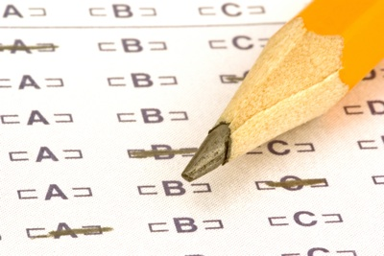

USA Test Prep
Visit usatestprep.com(follow the link) for assignments from your scholar's teacher or for practice on the standards. The login information is listed below. Please advise your scholar to NOT use their logins from previous years as they will NOT see their current content/grade level. Thank you.
Account ID: sandtown65
User ID: Last name, first initial [Example: crowderc]
Password: jagswag

