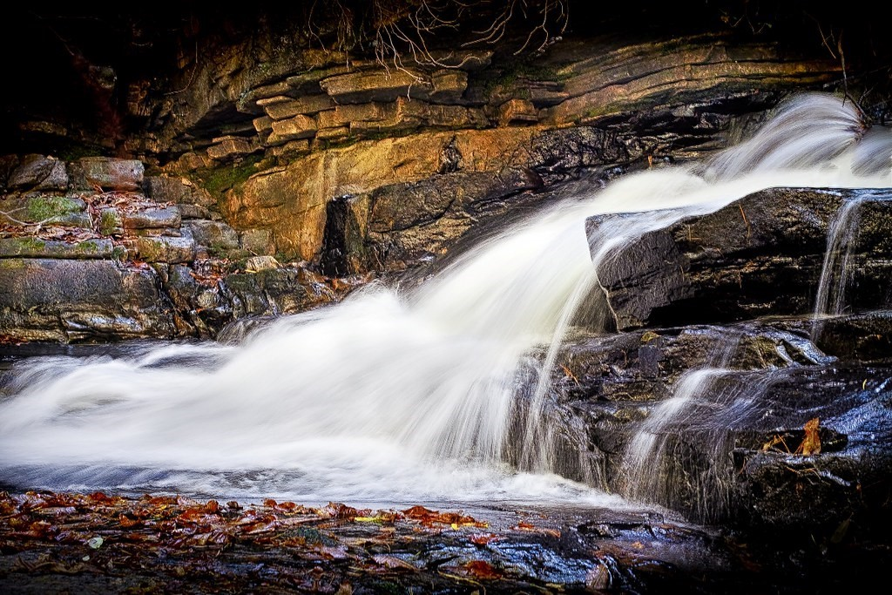

Major Assignments/Projects
1. Puzzle Posters- demonstrate how significant figures in history (James Oglethorpe, Tomochichi, and Mary Musgrove) helped establish Savannah in the Yamacraw Bluff. Research each individual and create a puzzle to “teach” your group about each individual. Teachers will provide a graphic organizer for notes.
2. Daily Life in Georgia Scrapbook- compose a scrapbook showing how students would live during the establishment of the colony of GA
3. Narrative Writing prompts
4. Primary Source Analysis
5. Graphic organizers (printed and available through Edmodo and Schoology)
6. Focus Lesson constructed response

