Gallopade Login Instructions

Scholars, please use the document below to assist you with logging in to Clickbook assignments through your workbook.

Step 1: Login to Launchpad from the FCS website.
Step 2: Click on the Social Studies icon found on the home page.
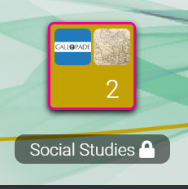

Step 3: Click on the Gallopade icon and this will lead you to your online workbook.
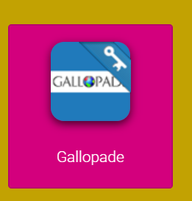

Step 4: For a Clickbook assignment, do NOT open the book. Only click on Assignments in the top right-hand corner.
